USING Horriblesub2Pulsar:

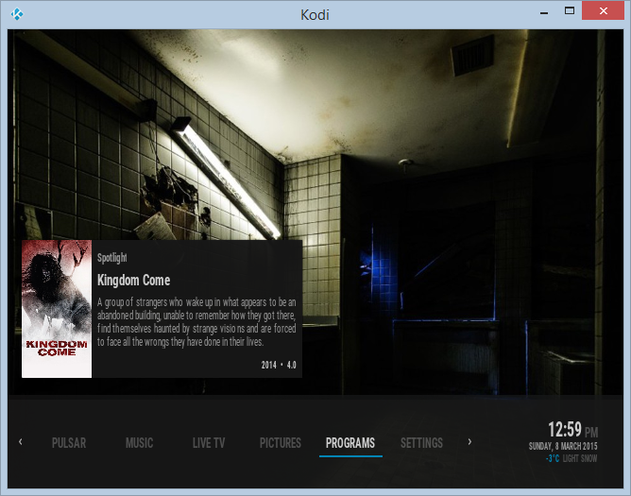

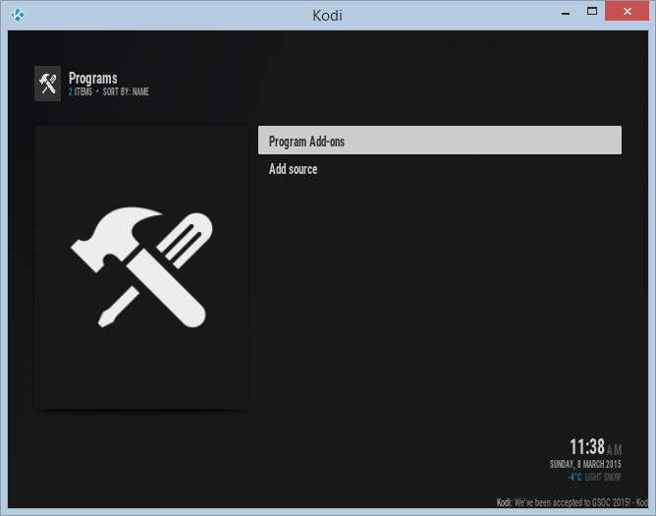

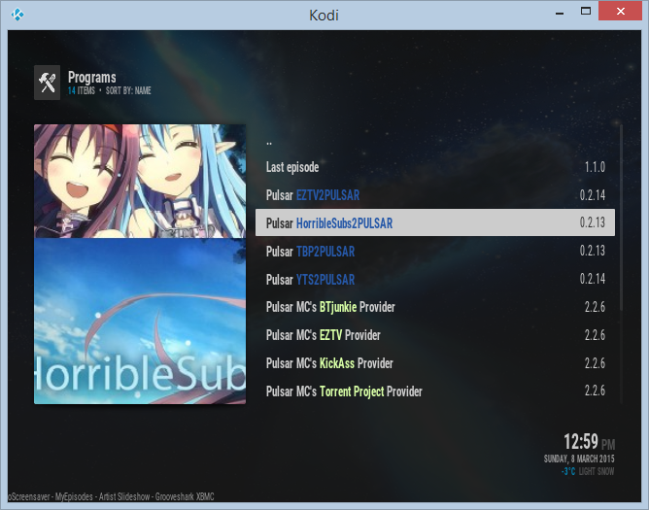

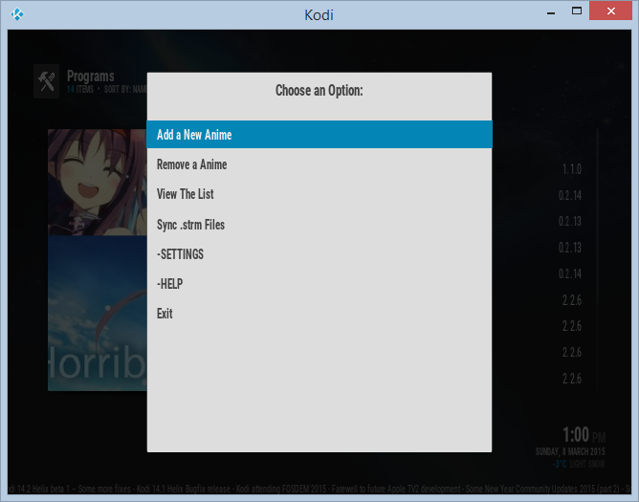

*Add a New Anime*: Allow to find and add a new anime to the list.

*Remove a New Anime*: Allow to erase an anime in the list.

*View the List*: It gives the list of show added.

*Sync .strm Files*: It check online the new episodes for the show added in the list.

*SETTINGS*: To change the script settings.

*HELP*: To find this guide.

*Exit*: To exit from the menu and the script.

# ADDING A NEW Anime

For example we want to add One Piece. We select the option Add a new Anime.

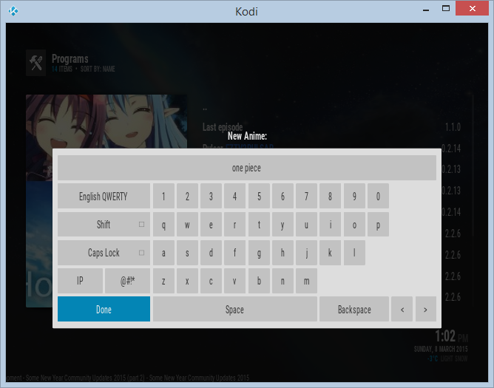

It is not necessary to write all the name. Just a keyword it is ok.

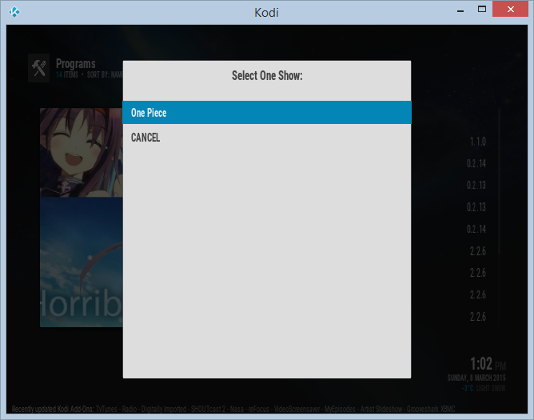

We select the show from the list of suggested animes

It is possible to cancel the operation selecting the option CANCEL.

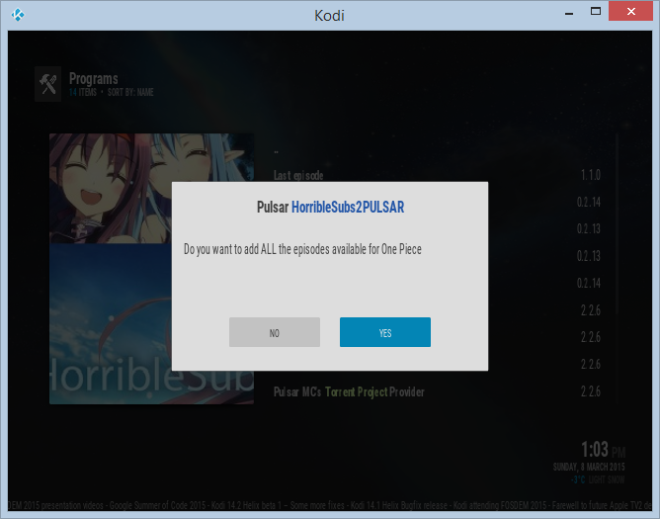

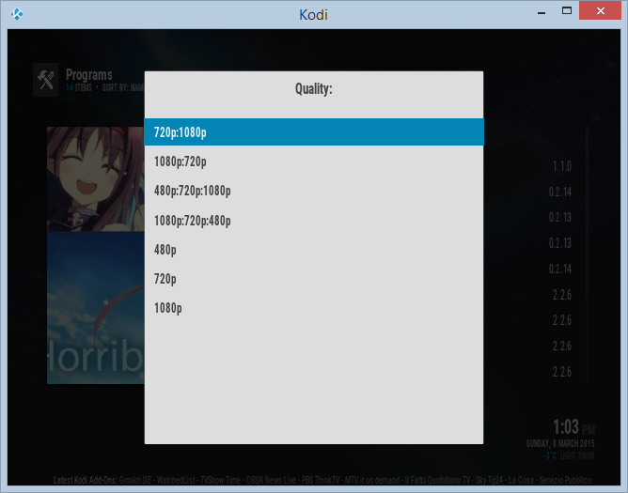

We select the quality:

*720p:1080p*: If the option of overwritten is off. It will search for 720p first. If it doesn't find any, it will check for 1080p.

*1080p:720p*: If the option of overwritten is off. It will search for 1080p first. If it doesn't find any, it will check for 720p, etc.

*480p:720p:1080p*: If the option of overwritten is off. It will search for 480p first. If it doesn't find any, it will check for 720p, etc.

*1080p:720p*:480p: If the option of overwritten is off. It will search for 1080p first. If it doesn't find any, it will check for 720p, etc.

*480p*: It only search for 480p episodes.

*720p*: It only search for 720p episodes.

*1080p*: It only search for 1080p episodes.

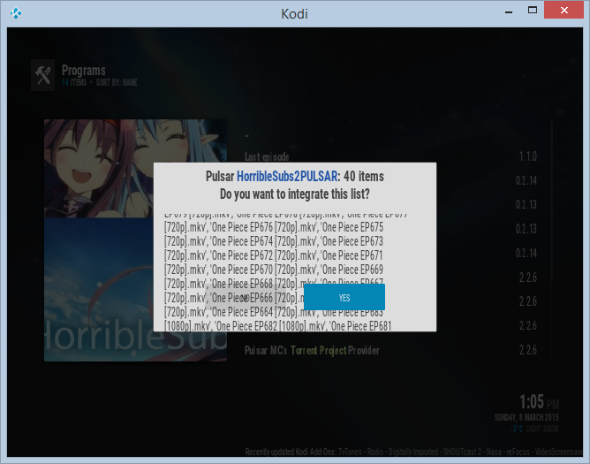

# SETTINGS

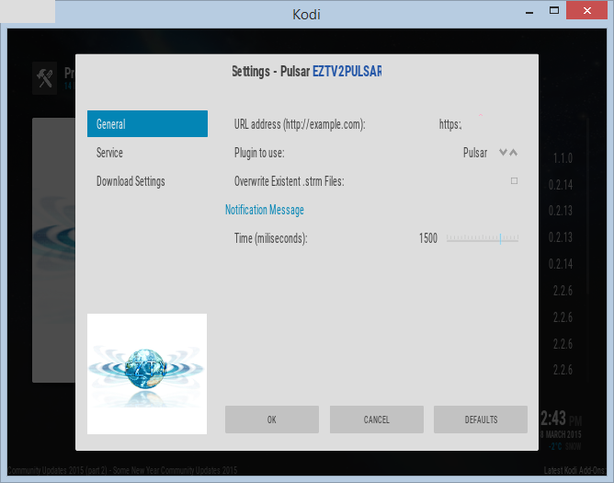

## General

*URL address*: The eztv url address.

*Plugin to use*: Select between Pulsar, KmediaTorrent and xbmctorrent to play the files.

*Overwrite files*: By default, the script doesn't overwrite files. But, if you need to do it. You need to enable this option.

*Notification message time*: It will config the time of the notifications. If you select zero, it won't have any notification.

## Service

If you want to run automatic the script in the start of Kodi, you need to enable this option.

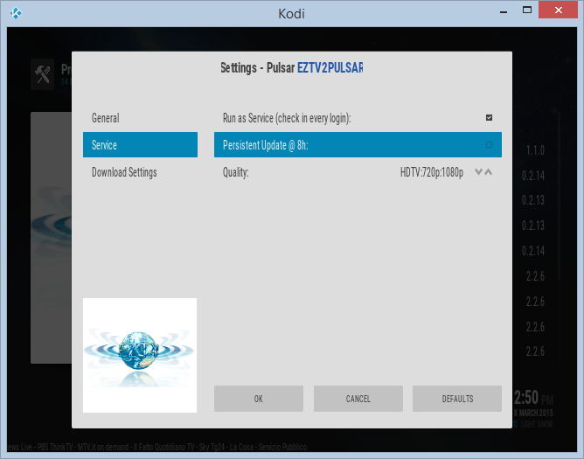

*Run as Service*: To enable the script to run at the start of Kodi. If you suspend your system, it won't run the next time. It only works when the system starts, no resuming from suspended.

*Persistent Update*: To run the script every 8h. If you have your system suspended, it will run the next that you turn on and it will resume every 8h.

*Quality*: Define which quality search (same criteria already explained).

## Download Settings

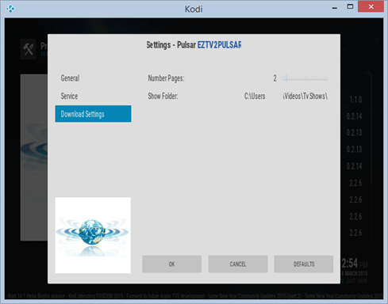

*Number Pages*: The site gives several pages of results. You can set-up how many pages you want that the script uses.

*Show Folder*: It will be the folder where you need to save the .strm files. That folder needs to be added as TV Show source in other to be update in the local library. Please, check this link: [Adding video sources](http://kodi.wiki/view/Adding_video_sources)

It is important to do this to allow Kodi to recognize the anime episodes:

